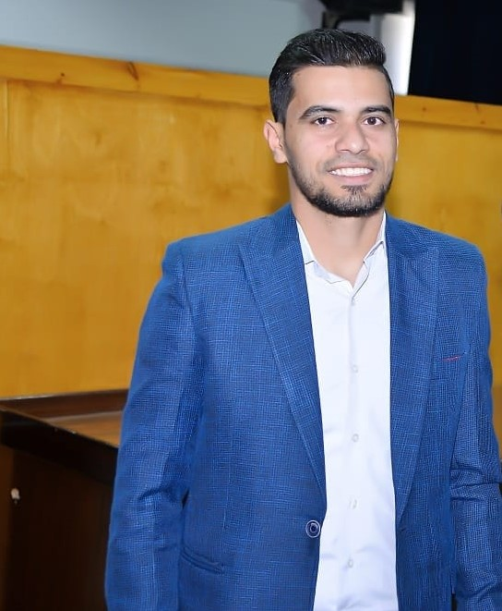
Curriculum Vitae

Name: Essmat Abdo Hamdan Allam

Nationality: Egyptian

Sex: Male

Date of Birth: April 23rd, 1995

Place of Birth: Assiut, Egypt

Marital Status: Married

Contact Address: Department of Pharmacology and Toxicology, Faculty of Pharmacy, Assiut University, Assiut, Egypt

Cell Phone Number: +201555949806

E-mail: essmatallam8@gmail.com
essmatallam@pharm.aun.edu.eg

Languages: fluent in Arabic and English

Education:
- Bachelors in pharmacy, Faculty of Pharmacy, Assiut University, Assiut, Egypt, June 2018.
- Grade: Excellent with Honors.
- MASTER DEGREE OF PHARMACEUTICAL SCIENCE (PHARMACOLOGY & TOXICOLOGY) Faculty of Pharmacy- Assiut university

Academic Positions
1- Demonstrator at Department of Pharmacology, Faculty of Pharmacy, Assiut University, Assiut, Egypt. (March 2019).
2- ASSISTANT LECTURER at pharmacology & toxicology department, faculty of pharmacy, Assiut university faculty of pharmacy, Assiut university. (July 2023).

Computer skills:
- Microsoft office word
- Power-point
- Excel
- Access
- Internet
- Graphpad prism
- Biorender
- Endnote
- MOE

